**IOT BASED SAFETY GADGET FOR CHILD SAFETY MONITORING AND NOTIFICATION**

**TEAM ID: PNT2022TMID37952**

**PROJECT REPORT**

**SUBMITTED BY**

**MADHUVANTHHI.S TEAMLEADER**

**POOJA.V TEAM MEMBER 1**

**SANGEETHA.R TEAM MEMBER 2**

**GLANY ROSE.P TEAM MEMBER 3**

# NEW PRINCE SHRI BHAVANI COLLEGE OF ENGINEERING AND TECHNOLOGY

|  |  |  |
| --- | --- | --- |
| **CHAPTER NO** | **TITLE** | **PAGE NO** |
| **1** | **INTRODUCTION**  1.1 Project Overview  1.2 purpose | **2** |
| **2** | **LITERATURE SURVEY**  2.1 Existing problem  2.2 References  2.3 Problem Statement Definition | **4** |
| **3** | **IDEATION & PROPOSED SOLUTION**  3.1 Empathy Map Canvas  3.2 Ideation & Brain Storming  3.3 Proposed Solution  3.4 Problem Solution Fit | **8** |
| **4** | **REQUIREMENT ANALYSIS**  4.1 Functional Requirement  4.2 Non-Functional Requirement | **14** |
| **5** | **PROJECT DESIGN**  5.1 Data Flow Diagrams  5.2 Solution & Technical Architecture  5.3 User Stories | **16** |
| **6** | **PROJECT PLANNING & SCHEDULING**  6.1 Sprint Planning & Estimation  6.2 Sprint Delivery Schedule  6.3 Reports from JIRA | **22** |

|  |  |  |  |
| --- | --- | --- | --- |
| **7** | **features ad code)**  7.1  7.2  7.3 | **CODING & SOLUTIONING (Explain the deed in the project along with**  Feature 1  Feature 2  Database Schema (if Applicable) | **25** |
| **8** | **TESTING**  8.1  8.2 | Test Cases  User Acceptances Testing | **29** |
| **9** | **RESULT**  9.1 | Performance Metrics | **34** |
| **10** | **ADVANTAGES & DISADVANTGES** | | **37** |
| **11** | **CONCLUSION** | | **39** |
| **12** | **FUTURE SCOPE** | | **41** |
| **13** | **APPENDIX** | | **43** |

CHAPTER -1

## INTRODUCTION

### 1.1 PROJECT OVERVIEW

The internet of things (IoT) refers to the set of devices and system that stay with real-world sensor

and to the internet. During years’ Child safety is under threat and it is very important to provide a technology based solution which will help them under panic situations and monitor them using a smart gadget. The proposed system is equipped with GSM and GPS modules for sending and receiving call and SMS between safety gadget and parental phone, the proposed system also consists of Wi-Fi module used to implement IoT and send all the monitoring parameters to the cloud for android app monitoring on parental phone. Android application can be used to track the current location of safety gadget using its location coordinates on parental phone android app and also via SMS request from parent phone to safety gadget. Panic alert system is used during panic situations and automatic SMS alert and phone call is triggered from safety gadget to the parental phone seeking for help and also monitored for plug and unplug from hand, as soon the gadget is unplugged from hand a SMS is triggered to parental phone and the alert parameter is also updated to the cloud.

### 1.2 PURPOSE

* As we all know, kids are the heartbeat of every parent, and when it comes to a child with special needs, parents have to be extra careful. They have to take extra care of their child.

* Child tracker help the parents in continuously monitoring the child's location. They can simply leave their children in school or parks and create a geo-fence around the location.

* By continuously checking the child's location notification will be generated if the child crosses the geo fence. Notification will be sent according to the child's location to their parents or caretakers. The entire location data will be stored in the database.

* child can also initiate emergency notification to the parents in case of unsafe situation.
* Enable tracking of the child's location and capturing of data remotely such as where the child located distance etc. To show the child's actual data with reference values

* Enable sending of notification if the child is out of location or when the device realizes abnormal condition or situation.

* Develop a prototype of IOT wearable smart band connected to parent's Mobile apps so, they can monitor the child activities from anywhere at anytime

.

# CHAPTER -2

**LITERATURE SURVEY**

**2.1 EXISTING PROBLEMS**

As we all know, kids are the heartbeat of every parent, and when it comes to a child with special

needs, parents have to be extra careful. They have to take extra care of their child. Child tracker helps the parents in continuously monitoring the child's location. They can simply leave their children in school or parks and create a geo-fence around the location. By continuously checking the child's location notifications will be generated if the child crosses the geo-fence. Notifications will be sent according to the child's location to their parents or caretakers. The entire location data will be stored in the database. Child can also initiate emergency notification to the parents in-case of unsafe situation. This research demonstrates Smart IoT device for child safety and tracking, to help the parents to locate and monitor their children. If any abnormal readings are detected by the sensor, then an SMS and phone call is triggered to the parents’ mobile. Also, updated to the parental app through the cloud. The system is equipped with GSM and GPS modules for sending and receiving call, SMS between safety gadget and parental phone. The system CHAPTER 2 also consists of Wi-Fi module used to implement IoT and send all the monitored parameters to the cloud for android app monitoring on parental phone. Panic alert system is used during panic situations alerts are sent to the parental phone, seeking for help also the alert parameters are updated to the cloud. Boundary monitoring system is implemented on safety gadget with the help of BEACON technology, as soon as the safety gadget moves far away from the BLE listener gadget an alert is provided to itself.

**2.2 REFERENCES**

**[1] SMART IOT DEVICEFOR CHILD SAFETYAND TRACKING:**

**Authors:** M Nandini Priyanka, S Maranga, K. N. H. Srinivas, T. D. S. Sarveswararao, E. Kusuma Kumari.

**Published in:** 2019 IEEE.

The system is developed using Link-It ONE board programmed in embedded C and interfaced with

temperature, heartbeat, touch sensors and also GPS, GSM&digital camera modules. The novelty of the work is that the system automatically alerts the parent/caretaker by sending SMS, when immediate attention is required for the child during emergency.

**Merits:**

The parameters such as touch, temperature & heartbeat of the child are used for parametric analysis

and results are plotted for the same.

**Demerits:**

To implement the IoT device which ensures the complete solution for child safety problems. **[2] CHILD SAFETY WEARABLE DEVICE: Authors**: Akash Moodbidri, Hamid Shahnasser **Published in**:2017 IEEE.

The purpose of this device is to help the parents to locate their children with ease. At the moment there

are many wearables in the market which helps to track the daily activity of children and also helps to find the child using Wi-Fi and Bluetooth services present on the device.

**Merits:**

This wearable over other wearable is that it can be used in any phone and it is not necessary that an

expensive smartphone is required and doesn’t want to be very tech savvy individual to operate.

**Demerits:**

As, this device’s battery gives short life-time. High power efficient model will have to be used which can

be capable of giving the battery life fora longer time.

1. **CHILD SAFETY&TRACKING MANAGEMENT SYSTEM BY USING: GPS Authors:** Aditi Gupta, VibhorHarit

**Published in**:2016 IEEE.

This paper proposed a model for child safety through smart phones that provides the option to track

the location of their children as well as in case of emergency children is able to send a quick message and its current location via Short Message services.

**Merits:**

The advantages of smart phones which offers rich features like Google-maps, PS, SMS etc.

**Demerits:**

This system is unable to sense human behaviour of child.

1. **CHILDREN LOCATIONMONITORING ON GOOGLEMAPS USING GPSAND GSM:**

**Authors:** Dheeraj Sunehera, Pottabhatini Laxmi Priya.

**Published in:**2016 IEEE.

This paper provides an Android based solution for the parents to track their children in real time. Different devices are connected with a single device through channels of internet. The concerned device is connected to server via internet. The device can be used by parents to track their children in real time or for women safety. The proposed solution takes the location services provided by GSM module. It allows the parents to get their child’s current location via SMS.

**Merits:**

A child tracking system using android terminal and hoc networks.

**Demerits**:

This device cannot be used in rural areas.

**2.3 PROBLEM STATEMENT DEFENITION**

There are multiple news-sharing apps used by a single user and are often spammed with

notifications. There is also a lot of fake news which gets shared. A news-sharing app wants to help users find relevant and important news easily every day and also understand explicitly that the news is not fake but from proper sources. While Opening app for reading a news, I’m literally getting too much of advertisements in- between the content because of these ads I was unable to read the content properly and it makes me feel irritated wants to help users find relevant and important news easily every day and also understand explicitly without the ads.

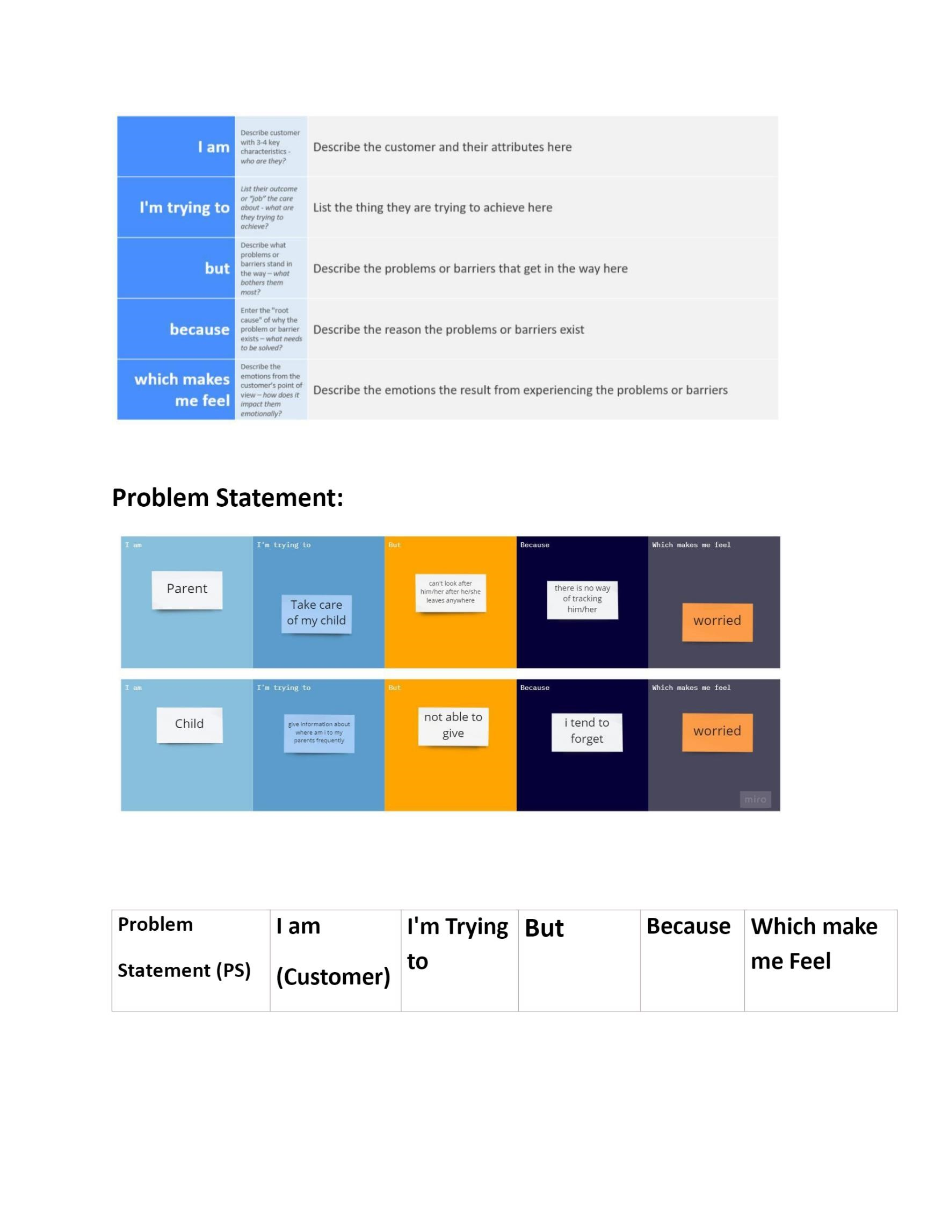

# CHAPTER -3

**IDEATION AND PROPOSED SOLUTION**

1. **1.EMPATHY MAP**

An empathy map is a simple, easy to digital visual that captures knowledge about user's behaviours

and attitudes. it is a useful tool hep teams better understand their users. Creating an effective solution requires understanding the true problem and the person who is experiencing it. the exercise of creating the map help participants consider things from the user's perspective along with his or her goals and challenge.

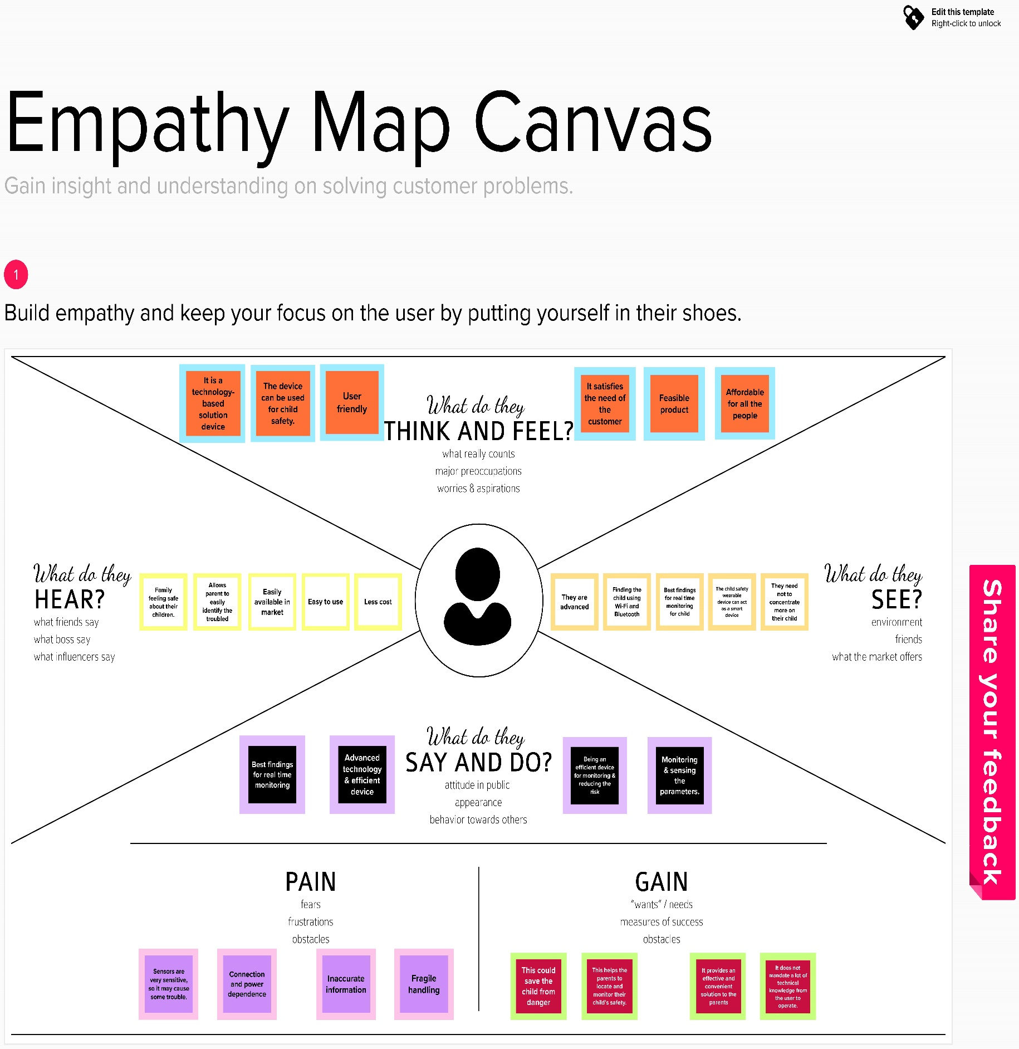

**3.2 IDEATION AND BRAINSTORMING**

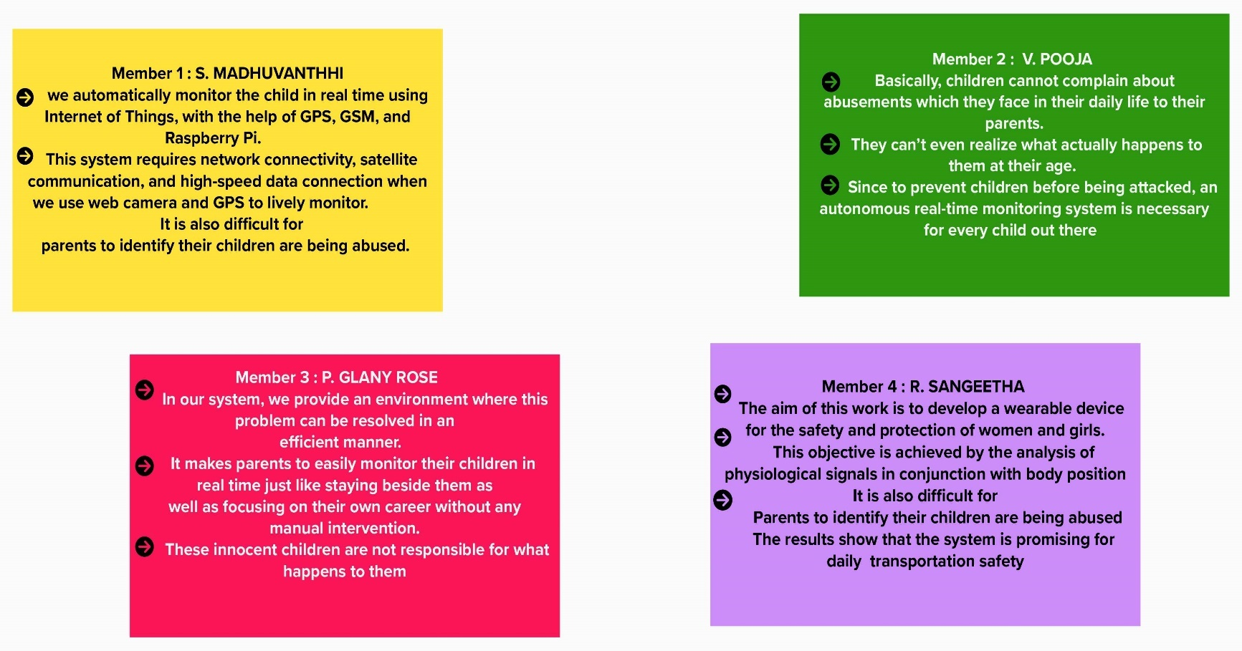

* 1. **PROPOSED SOLUTION**

|  |  |  |
| --- | --- | --- |
| **S.N.O** | **Parameter** | **Description** |
| **1.** | Problem Statement (Problem to be solved) | Risk alerts of the child. Hence, this device provides a security cover to the child in today’s time. |

|  |  |  |
| --- | --- | --- |
| **2.** | Idea / Solution description | The aim of this device is to provide safety to the child by allowing the parent to locate the child and view their surroundings. This device can be used to monitor the temperature and motion of the child. The other features of the device are emergency light and alarm buzzer which are activated when the button is pressed by the child in a distress situation to seek the attention of the bystanders. If any abnormal values are read by the sensor, then an SMS is sent to the parents mobile and an MMS indicating an image captured by the serial camera is also sent. |
| **3.** | Novelty / Uniqueness | The enchantments will be adding more features, software, applications, hardware to make the proposed system. |

|  |  |  |
| --- | --- | --- |
| **4.** | Social Impact/ Customer Satisfaction | The authors tested the system against different types of users. The feedbacks of parents and children were highly promising. Results showed that 86.4% of the parents are satisfied with the time controller, around 91.1% of the children are satisfied with the proposed interface and 100% of the children are satisfied with the multiple sessions of the time allowed and video algorithm. |

|  |  |  |
| --- | --- | --- |
| **5.** | Business  Model  (Revenue  Model) | Iot based risk monitoring device for child is done through smart device i.e., smart watch. Through this device the respected parameters are monitored by the connected person. |
| **6.** | Scalability of the Solution | It can be given up to 9 out of 10. |

* 1. **PROBLEM SOLUTION FIT**

|  |  |  |
| --- | --- | --- |
| **1.CUSTOMER SEGMENT**  Who is your customer?  i.e., working parents of 0-5 you. Kids  Parents are the customer | **6. CUSTOMER CONSTRAINTS**  What constraints prevent your customers from taking action or limit their choices  of solutions? i.e., spending power, budget, no cash, network connection, available devices.  For predictive analytics to make the most impact on child protection practice and outcomes, it must embrace established criteria of validity. | **5. AVAILABLE SOLUTIONS**  Which solutions are available to the customers when they face the problem  or need to get the job done? What have they tried in the past? What pros & cons do these solutions have? i.e., pen and paper The most important reason for monitoring each child ‘development is to determine whether a child's development. Looking for developmental milestones is important to understanding each child's development and behaviour. |
| **2. JOBS-TO-BE-DONE / PROBLEMS**  Which jobs-to-be-done (or problems) do you address for your customers? There could be more than one; explore different sides.  Overparenting tends to deprive children of bad and negative experiences, which are crucial to a child’s emotional growth. One form of overparenting is excessive monitoring. | **9. PROBLEM ROOT CAUSE**  What is the real reason that this problem exists? What is the back It’s exactly what it sounds like—an exercise to determine the root cause for a failure or issue, so that the solution is based on the true problem, not just addressing the symptoms | **7. BEHAVIOUR**  What does your customer do to address the problem and get the job done?  When children have frequent emotional outbursts, it can be a sign that they haven’t yet developed the skills they need to cope with feelings like frustration, anxiety and anger. Handling big emotions in a healthy, mature way requires a variety of skills, including. |
| **3. TRIGGERS**  What triggers customers to act?  i.e., seeing their neighbour installing solar panels, reading about a more efﬁcient solution in the news.  It’s not the situation or the feeling that’s the problem; it’s how kids think about these things and what they say to themselves that causes problems. trigger | **10. YOUR SOLUTION**  If you are working on an existing business, write down your current solution ﬁrst, ﬁll in the canvas, and check how much it ﬁts reality.  If you are working on a new business proposition, then keep it blank until you ﬁll in the canvas and come up with a solution that ﬁts within customer limitations, solves a problem and matches customer behaviour.   * The most important reason for monitoring each child's development is to determine whether a child's development is on track. Looking for developmental milestones is important to understanding each child's development and behaviour. | 1. **CHANNELS of BEHAVIOUR**   **ONLINE**  What kind of actions do customers take online? Extract online channels from #7  **OFFLINE**  What kind of actions do customers take ofﬂine? Extract ofﬂine channels from #7 and use them for customer development. Understanding how children perceive and interact with the point of sale has been the focus of various studies in the past decade. It is well documented that children have preferences in terms of shopping destinations |

|  |
| --- |
| **4. EMOTIONS: BEFORE / AFTER**  How do customers feel when they face a problem or a job and afterwards?  i.e., lost, insecure > conﬁdent, in control - use it in your communication strategy & design.  BEFORE: Divergent thinking is a style of thinking that generates a range of alternative solutions or ideas to a problem that has multiple answers.  AFTER: Feeling protective of your child is often manifested in the form of ‘motherly’ instincts. The feeling of protecting and wanting the best for your children is the ultimate parenting goal. |

# CHAPTER -4

**REQUIREMENT ANALYSIS**

**4.1 FUNCTIONAL REQUIREMENTS**

Following are the functional requirements of the proposed solution.

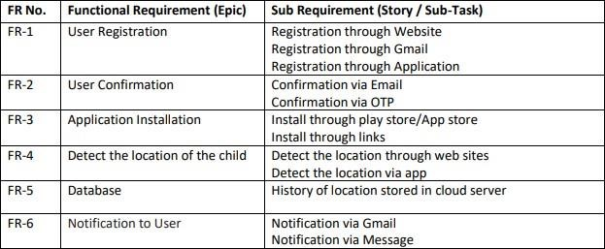

**4.2 NON-FUNCTIONAL REQUIREMENTS**

Following are the non-functional requirements of the proposed solution.

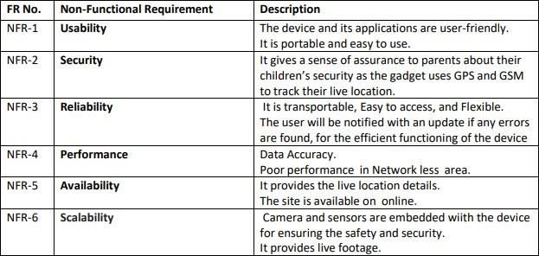

# CHAPTER -5

## PROJECT DESIGN

**5.1 DATA FLOW DIAGRAM**

IOT based safety gadget for child safety monitoring and notification

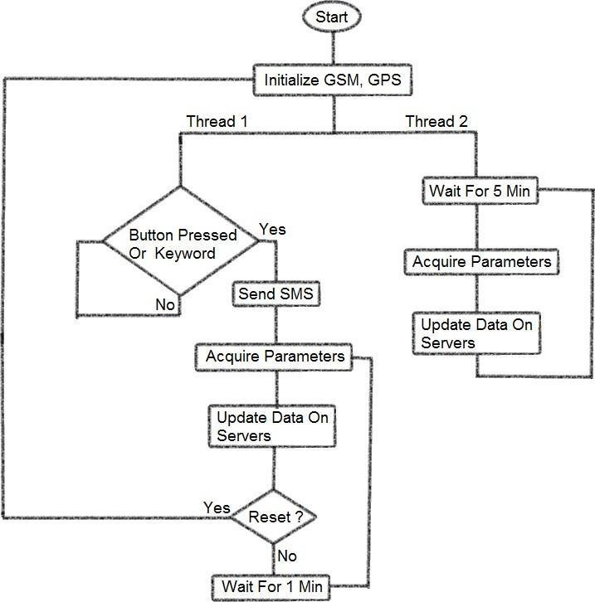

**5.2 SOLUTION AND TECHNICAL ARCHITECTURE**

Solution architecture is a complex process – with many sub-processes – that

bridges the gap between business problems and technology solutions. Its goals are to:

* Find the best tech solution to solve existing business problems.

* Describe the structure, characteristics, behaviour, and other aspects of the software to project stakeholders.

* Define features, development phases, and solution requirements.

* Provide specifications according to which the solution is defined, managed, and delivered.

**TECHNICAL ARCHITECTURE**

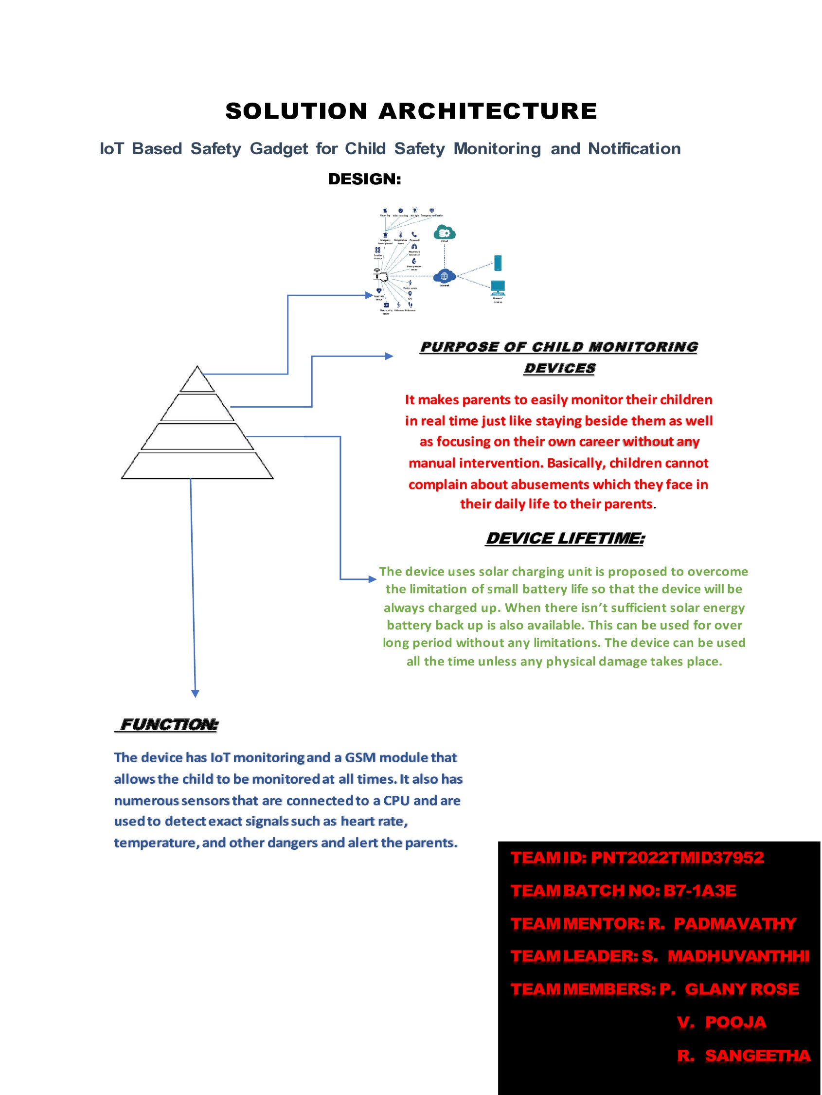

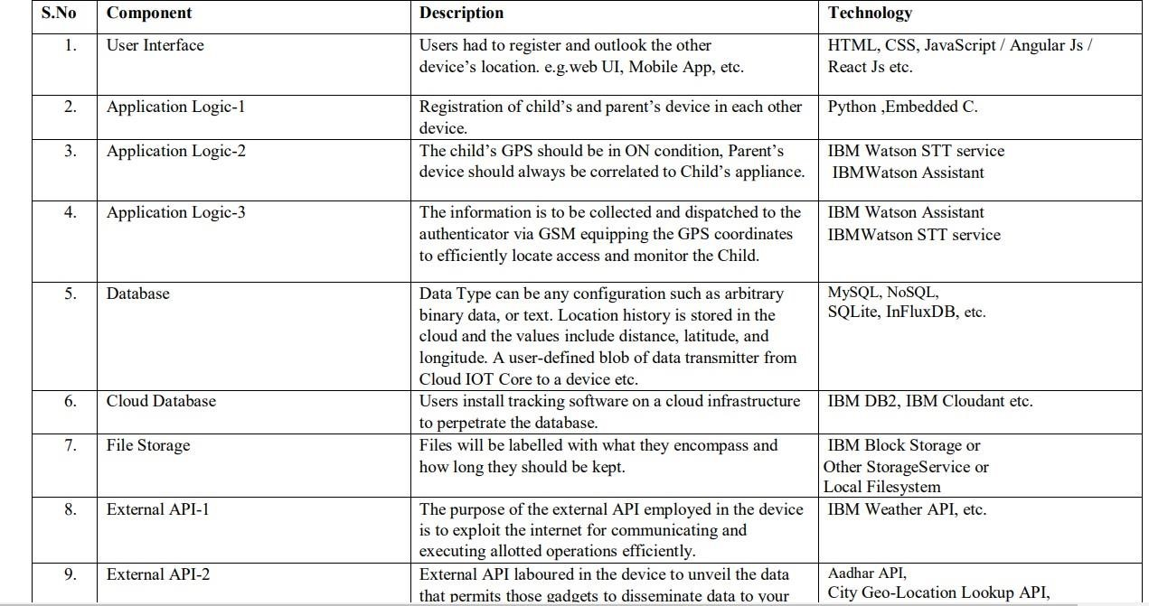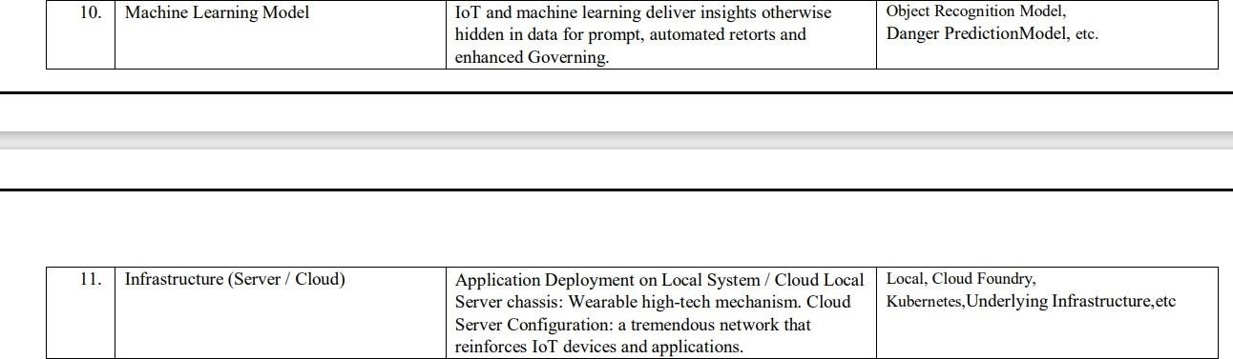**Table-1: Components & Technologies:**

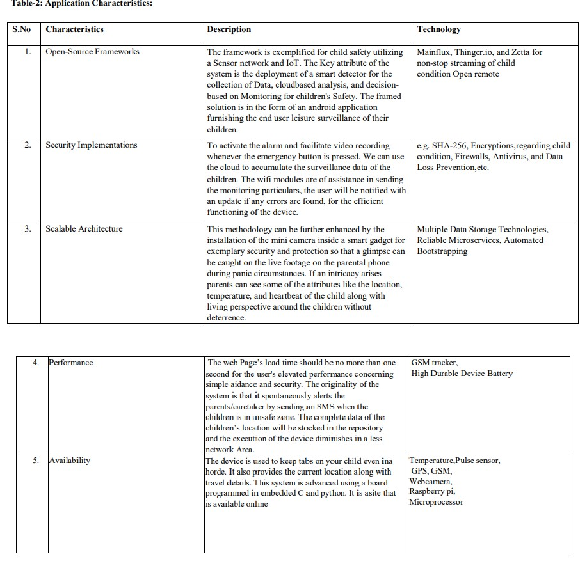

# CHAPTER -6

**CHAPTER 6**

**PROJECT PLANNING AND SCHEDULING**

**6.1 SPRINT PLANNING AND ESTIMATION**

|  |  |  |  |  |  |  |  |
| --- | --- | --- | --- | --- | --- | --- | --- |
| **Sprint** | **Functional**  **Requirement (Epic)** | **User Story**  **Number** | **User Story / Task** |  | **Story Points** | **Priority** | **Team Members** |
| Sprint-1 | Registration | USN-1 | As a Parent/Guardian, I can register for the application by entering my email, password, and confirming my password. | 2 |  | High | Madhuvanthhi.S |
| Sprint-1 |  | USN-2 | As a Parent/ Guardian, I can register for the application through Gmail | 1 |  | Medium | Glany Rose. P |
| Sprint-1 | User Confirmation | USN-3 | As a parent I will receive connection, location in SMS / mail once I have entered this application | 1 |  | High | Pooja. V |
| Sprint-1 | Login | USN-4 | As a parent/ guardian, I can log into the application by entering mail and password. | 2 |  | High | Sangeetha. R |

**6.1 SPRINT DELIVERY SCHEDULE**

|  |  |  |  |  |  |  |
| --- | --- | --- | --- | --- | --- | --- |
| **Sprint** | **Total Story Points** |  | **Sprint Start Date** | **Sprint End Date (Planned)** | **Story Points**  **Completed (as on**  **Planned End Date)** | **Sprint Release Date (Actual)** |
| Sprint-1 | 20 |  | 04 Nov 2022 | 5 Nov 2022 | 20 | 26 Nov 2022 |

|  |  |  |  |  |  |  |
| --- | --- | --- | --- | --- | --- | --- |
|  |  |  |  |  |  |  |
| Sprint-2 | 20 |  | 06 Nov 2022 | 07 Nov 2022 | 20 | 26 Nov 2022 |
| Sprint-3 | 20 |  | 08 Nov 2022 | 09 Nov 2022 | 20 | 26 Nov 2022 |
| Sprint-4 | 20 |  | 10 Nov 2022 | 12 Nov 2022 | 20 | Nov 2022 |

**Velocity:**

Imagine we have a 10-day sprint duration, and the velocity of the team is 20 (points per sprint). Let’s calculate the team’s average velocity (AV) per iteration unit (story points per day)

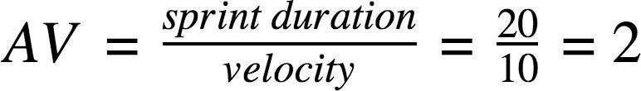

**6.1 REPORT FROM JIRA**

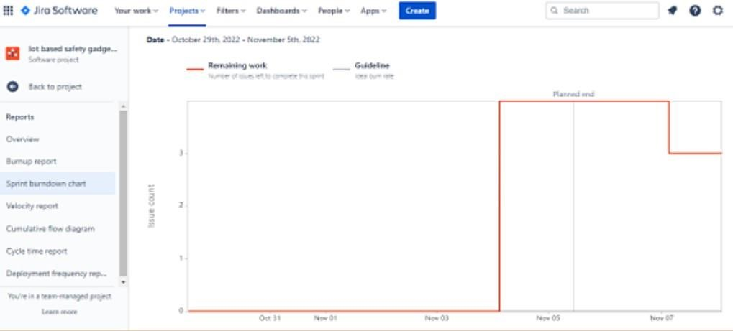

26

**CHAPTER -7**

27

**CODING & SOLUTIONING (Explain the features added in the project along with code)**

**7.1 FEATURE import json**

**import wiotp.sdk.device import time**

**myconfig = {**

**"identity": {**

**"orgId": "u5k7qv",**

**"typeId": "SAFETY-GADGET",**

**"deviceId": "SAFETY_GADGET_1"**

**},**

**"auth": {**

**"token":" qFA7m1REHT?PvWXu@e "**

**}**

**}**

**client = wiotp.sdk.device.Deviceclient(config=myconfig, logHandlers=None) client.connect()**

**while True:**

**name= "Smartbridge" latitude=17.4219272 longitude=78.5488783**

**myData={'name': name, 'lat': latitude,'lon': longitude}**

**client.publishEvent(eventId="status",msgformat="json", data=mydata, qos=0, onpublish=None) print("Data published to IBM IOT platform :",myData) time.sleep(5)**

**client.disconnect()**

**7.2 FEATURE**

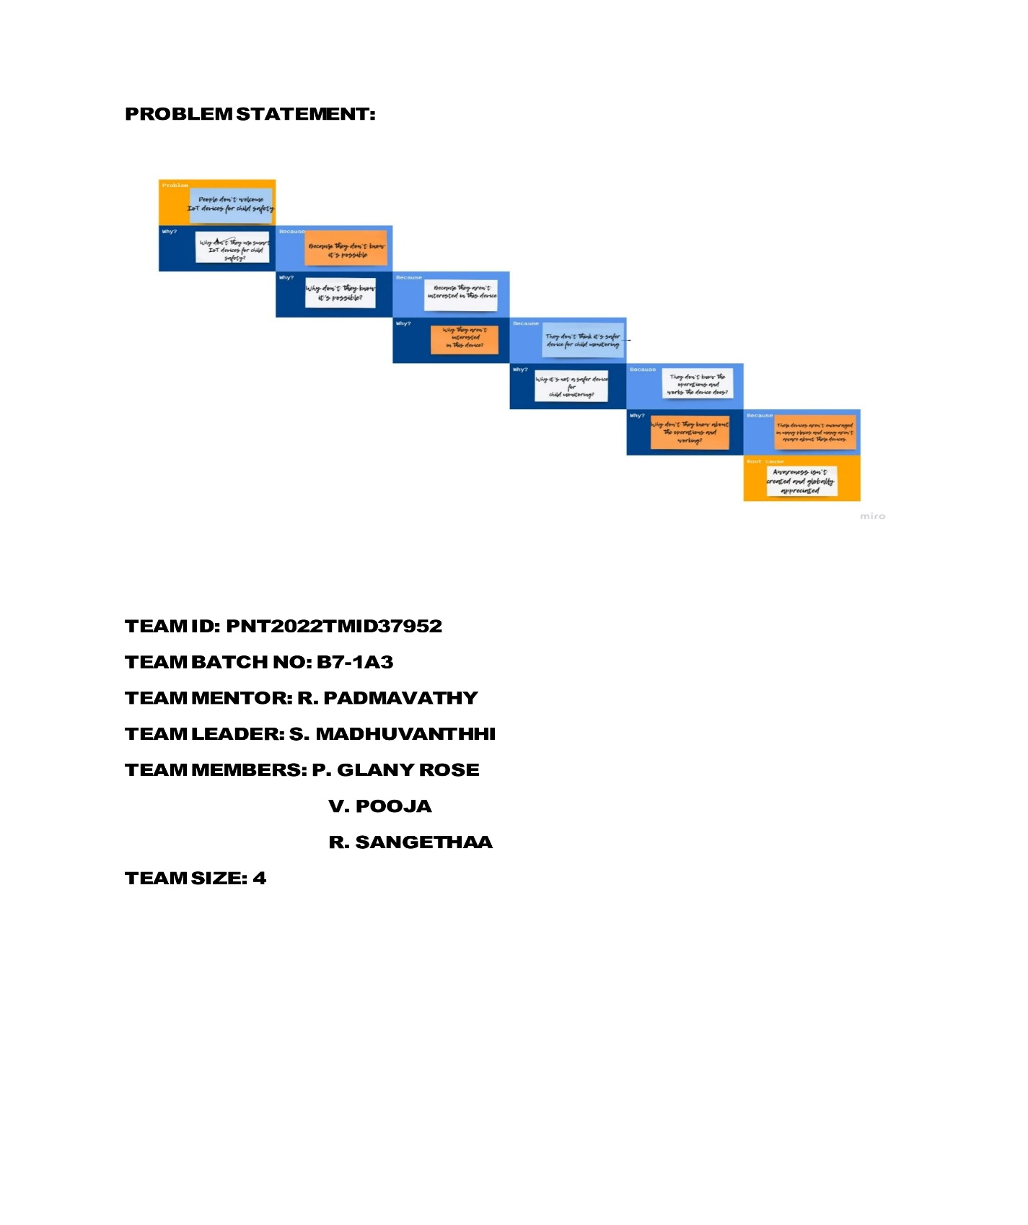

**7.3 Database Schema (if Applicable)**

MIT App

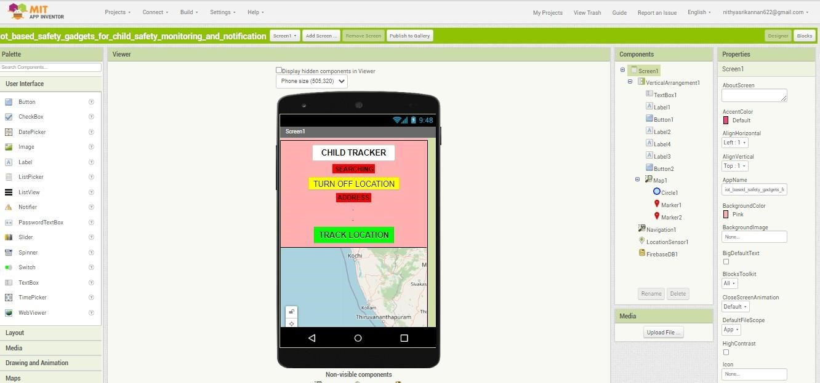

MIT App Code

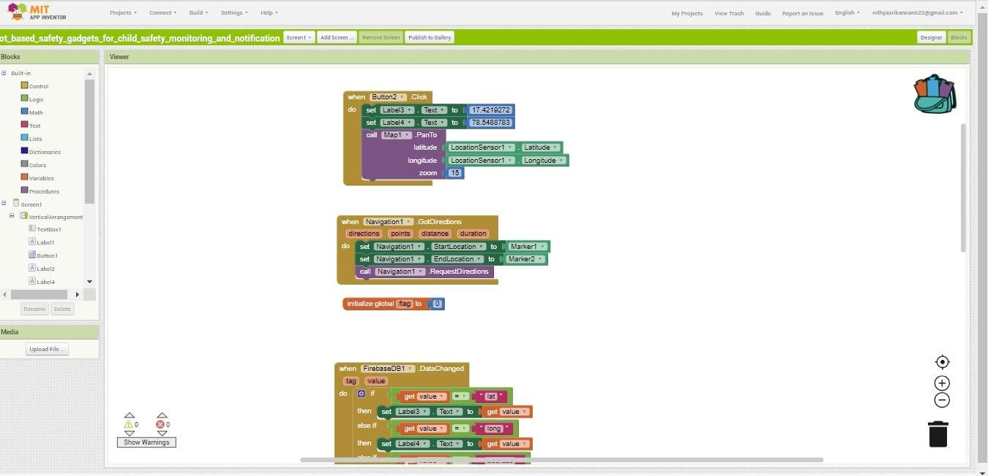

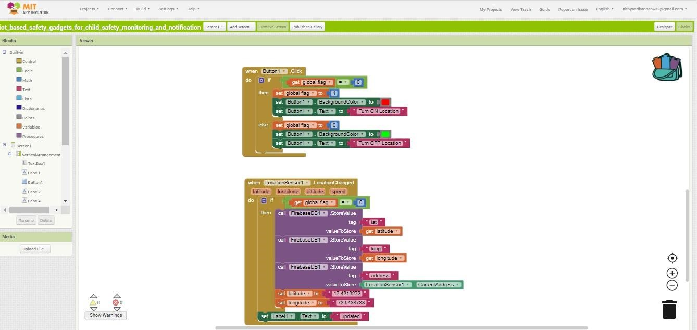

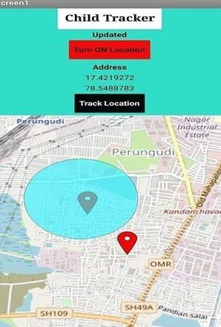

# CHAPTER -8

**TESTING**

**8.1 Test Cases**

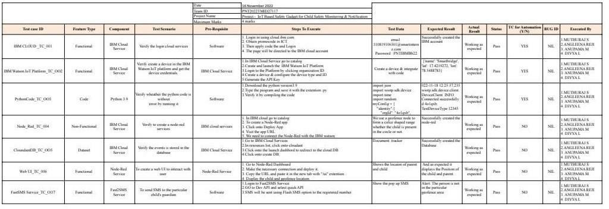

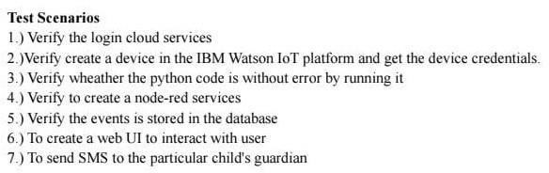

**Nod Red Connection**

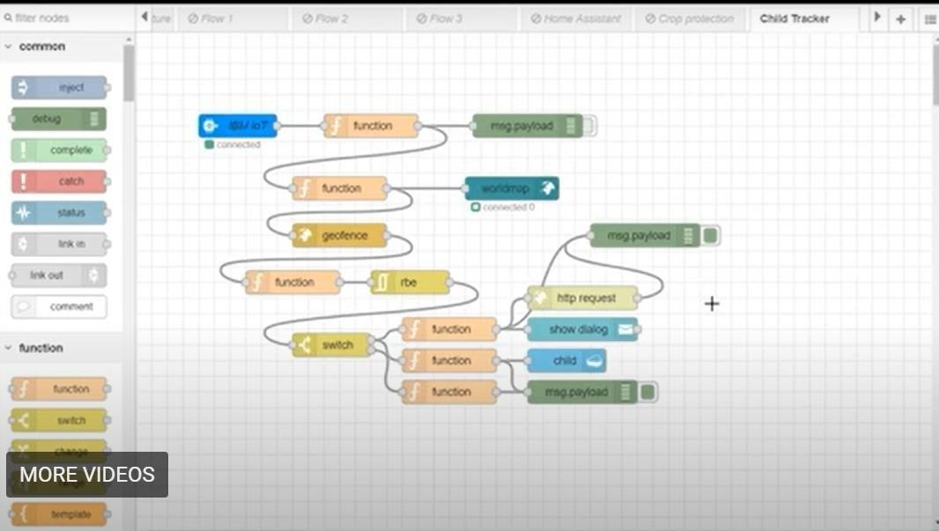

**output**

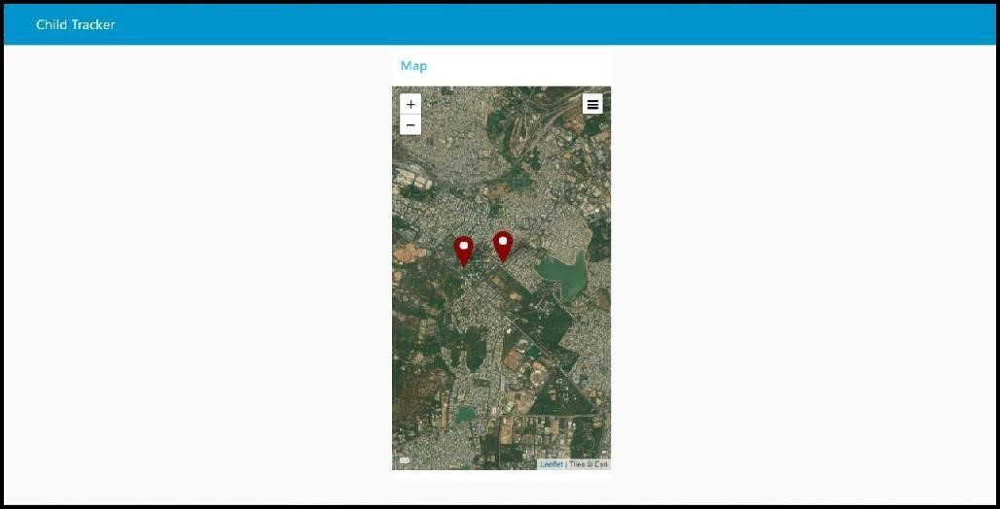

**8.2 User Acceptances Testing**

.

**Acceptance Testing UAT Execution & Report Submission**

|  |  |
| --- | --- |
| Date | 25 November 2022 |
| Team ID | PNT2022TMID37952 |
| Project Name | Project – IoT based safety gadget for child safety monitoring and notification |
| Maximum Marks | 4 Marks |

**Purpose of Document**

The purpose of this document is to briefly explain the test coverage and open issues of the [Product Name] project at the time of the release to User Acceptance Testing (UAT).

# CHAPTER -9

**RESULT**

## 9.1 Performance Metrics

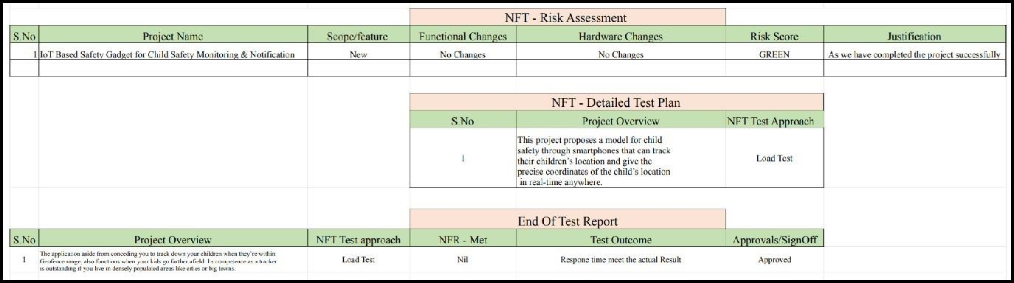

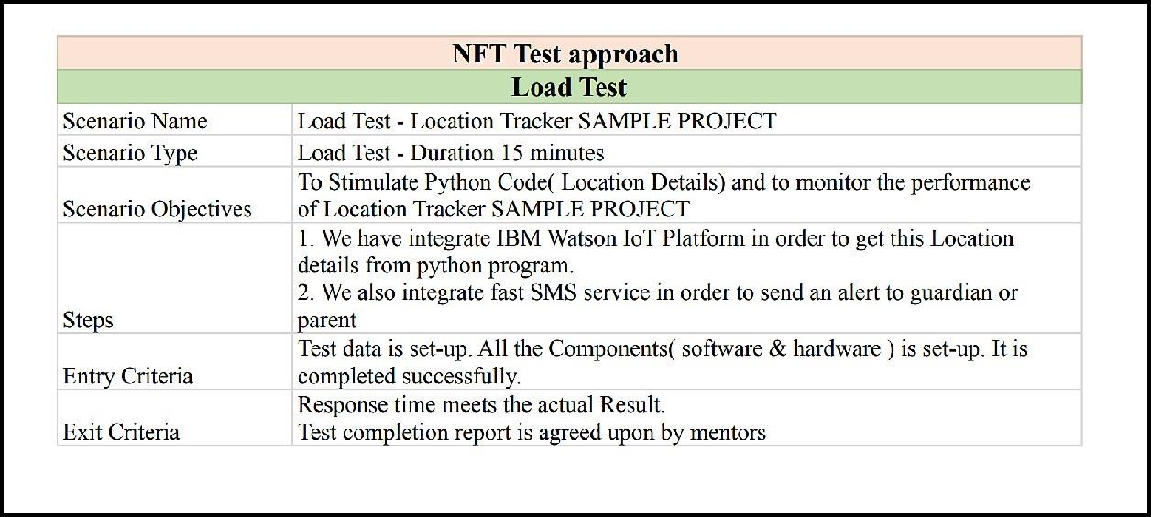

# CHAPTER -10

## ADVANTAGES AND DISADVANTAGES

**ADVANTAGES:**

* Keeps track of children in case of abduction.
* Allows children more freedom while being watched.
* Monitors children with special needs who wander.
* Helps monitor children with behavioural problems.
* Gives peace of mind to parents.

**DISADVANTAGES**

* The system is dependent on communication signal/network signal for the smart gadget to trigger

automatic phone call/SMS during panic situation.

* It can be difficult to detect when network signal is not reachable/weak/when the smart gadget moves

outside the boundary range.

* Improved by increasing the range
* Children may feel a loss of privacy.
* Losing confidence

# CHAPTER -11

## CONCLUSION

The System put forward this paper to ensure the safety of children and increase their confidence. Many experimenters are operating in this area and have formulated different technologies to aid children. The key represented in this paper takes the advantage of smartphones which proposes affluent elements like Google maps, SMS, etc. The child safety and protection device is proficient in acting as a smart IoT device. It equips parents with real-time location, the surrounding temperature, and along with an alarm buzzer for their child’s circumstances and the capability to locate their child. This paper depicts the fundamental design concept and functionality along with the anticipated consequence.

The application aside from conceding you to track down your children when they’re within Bluetooth

range, it also functions when your kids go farther afield. Its competence as a tracker is outstanding and if you live in densely populated areas like cities or big towns. This means you will be able to see the identity of the participating devices and It helps to diminish their vulnerability in harmful situations and also protects the children in emergency situations.

Parents take measures both at home and outdoors to safeguard their kids from hurting themselves. But sometimes, it's impossible to pre-empt what can cause a treacherous encounter. However, it's possible to prevent such hazards with some forethought and simple measures using these safety gadgets.

# CHAPTER -12

## FUTURE SCOPES

**Ceaseless Surveillance:**

If any deviant readings are disclosed by the sensor, then an SMS and phone calls are set off to the parent's

mobile.

**Create unassailable environment:**

Precisely predicting the circumstances of the children and swiftly sensing the problems around children will

make parents at ease. It helps to diminish their vulnerability in harmful situations and also protects the children in emergency situations.

**Pays way for a tech-driven community:**

Children and their parents are veering around to digital solutions more than ever to support children's

cognition and it notifies the information about the child in a web application

# CHAPTER -13

## APPENDIX

**GITHUB LINK:**

https://github.com/IBM-EPBL/IBM-Project-46447-1660747301